**MARINA FLEET**

USER GUIDE

|  |  |  |
| --- | --- | --- |
| SUPERVISOR | **Sir Sajid Mehdi** | |
| BATCH | **202012C** | |
| GROUP | **1** | |
| SERIAL NUM | **Enrollment Number** | **Student Name** |
| 1 | **1288068** | **Syed Faraz Ali** |
| 2 | **1297067** | **Saad Khan** |
| 3 | **1293769** | **G. Mustufa** |

# **OBJECT OF THE PROJECT**

The object of this program is to give a sample project to work on real life projects. These application help you build a larger more robust application.

The objects is not to teach you HTML/JavaScript/ visual studio code but to program with a real life scenario and helo you creat basic application using the tools.

You can revise the chapters before you start with the project.

This project is meant for students who have completed the module of **visual studio code**. These programs should be done in the lab session with assistance of thr faculty if required.

It is very essential that a student has a clear understanding of the subject. Students should go through the project and solve the assignments as per requirments given.

Kindly get back tp eProjects Team in case of any double regrading the appilication or its objectives.

# **PROBLEM STATEMENT**

Marina Fleet website will present the information about the various fleets off yachts and boats available with them. The website will help the customers in choosing the yacht or boat as per their requirements. The company may also be benefitted with the information available on the website in reaching to wide range of customers.

# **CUST0MER REQUIREMENT SPECIFICATIONS**

The web site is to be created base on the following requirements.

1. The Home Page should be created masking use of Section with a suitable logo, the header section can be added which will show images yachts and boats
2. The site must contain the links to navigate through a category for the information.
3. Links of fleets can be categorized like (Luxury, Sailing, Fishing etc.)
4. Specification and Pricing of Yacht/Boat can be added along with images.
5. Gallery section can be added for viewing different image
6. Feedback must be allowed to enter by the viewer.
7. Site map, Gallery about us, Queries link, contact us link must be added
8. The complete description must be allowed to get download as pdf for doc file.
9. The advertise section with various facilities provided should be mentioned.

# **GUI STANDARD DOCUMENTS**

The graphical user interface (GUI) of our website is very user friendly through a user can easily find out different types of yachts and boats.

## **CORE FEATURES**

We provide a lots of features in our Marina Fleet website. Some of them are given below.

* User can navigate to different sections of our website through **navigation bar.**
* Below the **navigation bar** in our main page, Hero section is mentioned which is made through carousel slider.
* After the **Hero section**, there are two more sections, one is **featured section** which shows some featured yachts & boats and the other is **our services** which describes our uniqueness in the market.
* **For sale section** is just below that section which features almost every types of boats & yachts.
* **Gallery section** is made to show some beautiful boats & yachts images to the user.
* Below the gallery section **contact-us** form is present which allows user to contact us and can give his feedback on our website.
* User can directly jump to **categories page** through navigation bar by link mentioned as categories.
* **Detail page** is to specify our boats and yachts in more detail.
* There are links (Buttons) through a user can directly book yachts and boats of their choice through booking page.
* This website is developed by mainly **HTML, CSS, JavaScript, JQuery Plugins & Bootstrap.**

# **SCREENSHOTS OF DIFFERENT SECTIONS**

**NAVBAR AND HERO SECTION**

## 

## **FEATURED SECTION**

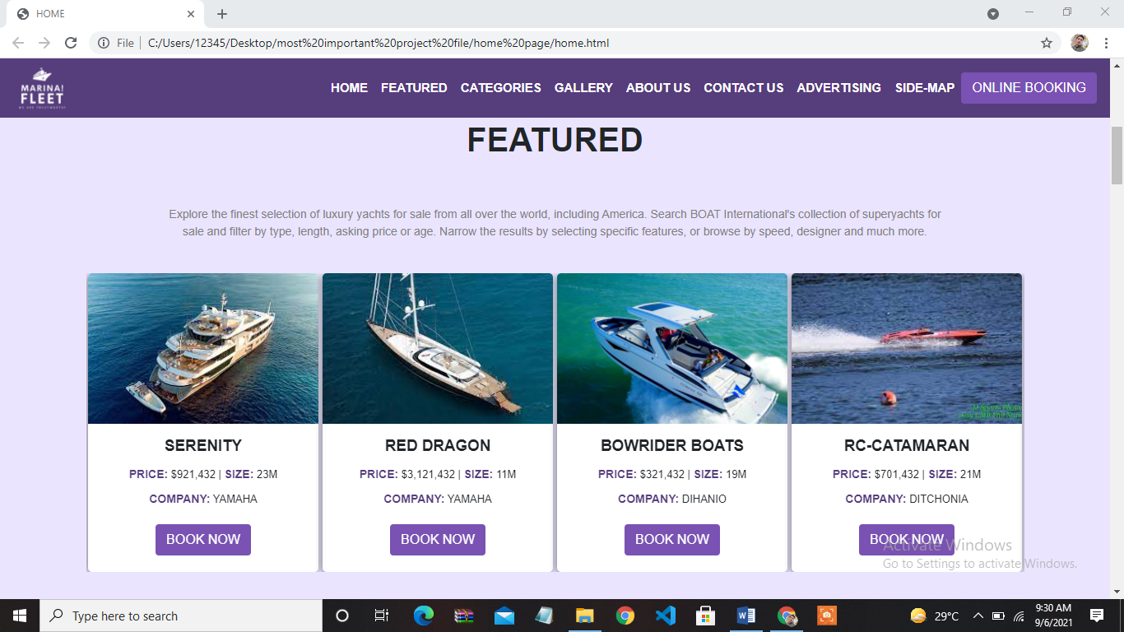

## **OUR SERVICES**

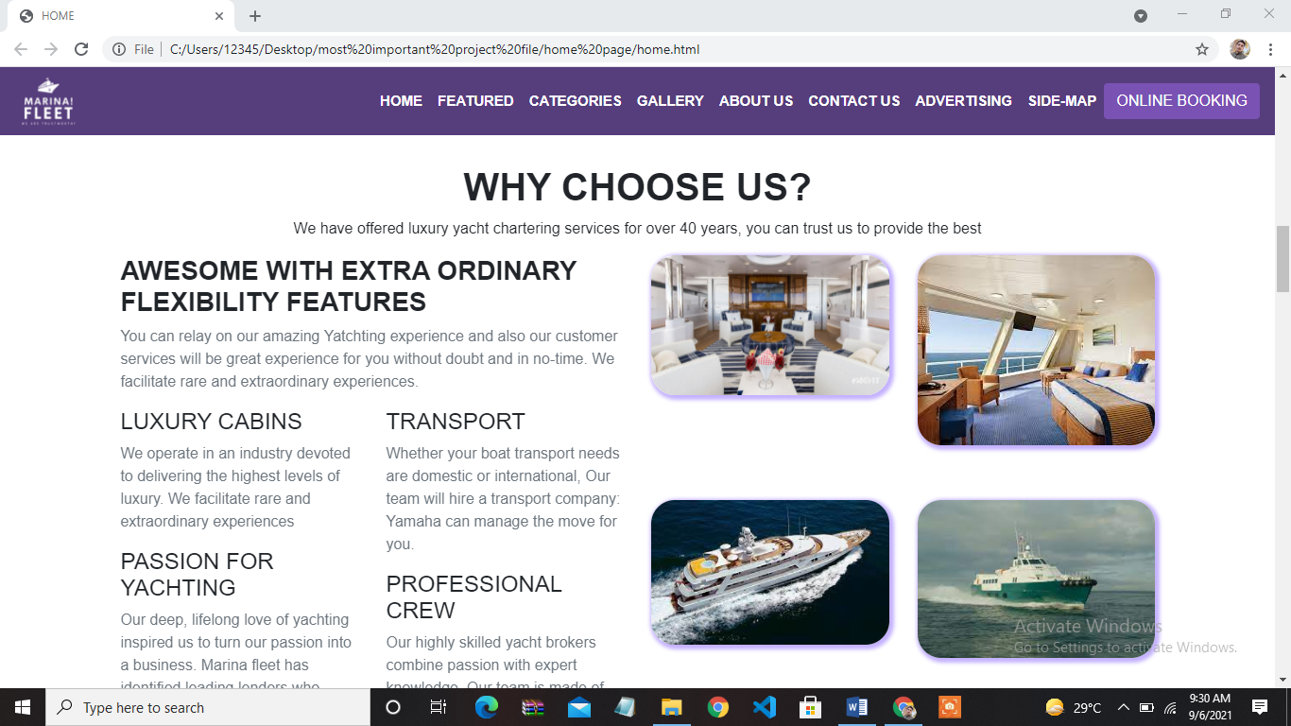

**FOR SALE SECTION**

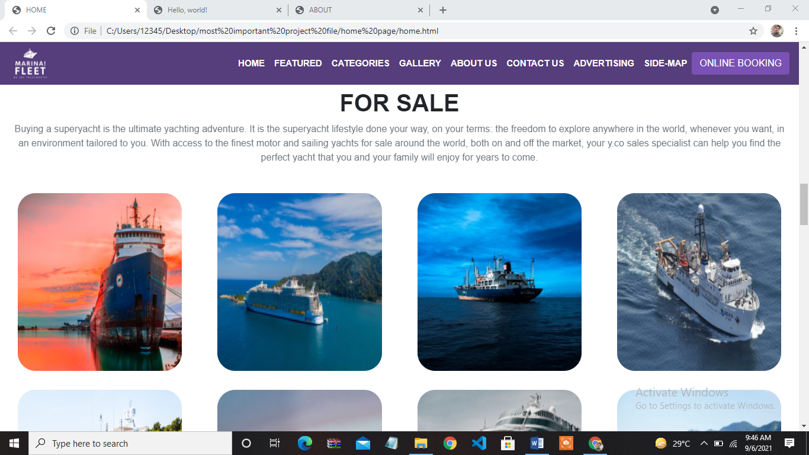

**GALLERY SECTION**

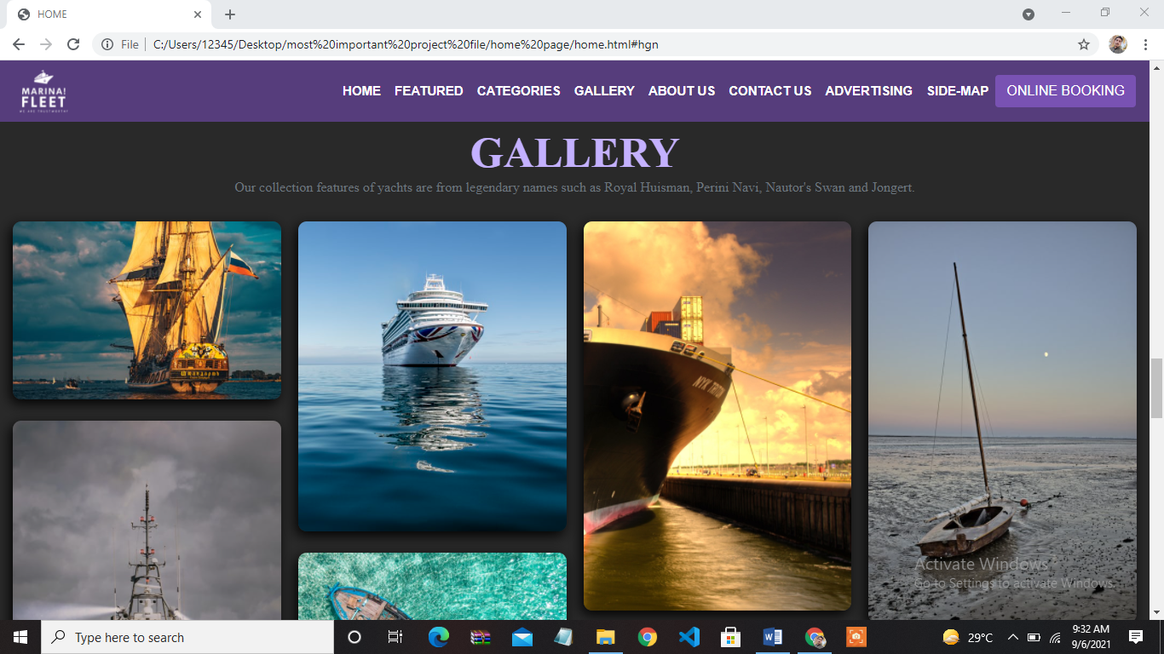

**CONTACT-US FORM**

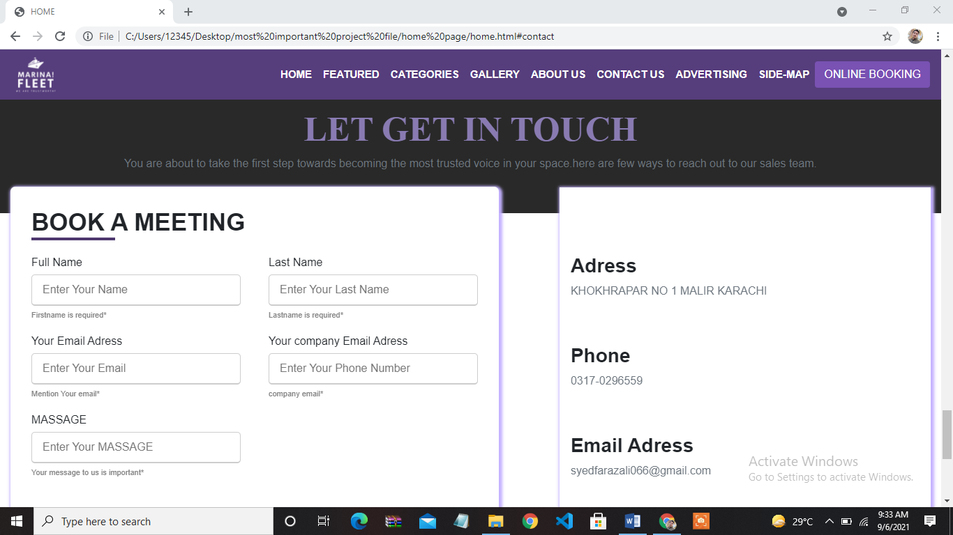

**CATEGORIES PAGE**

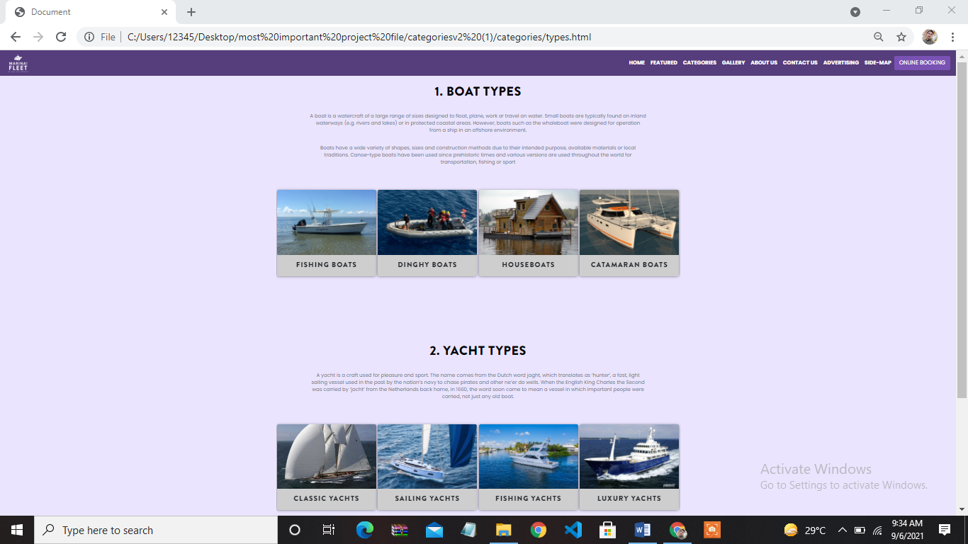

**DETAIL PAGE**

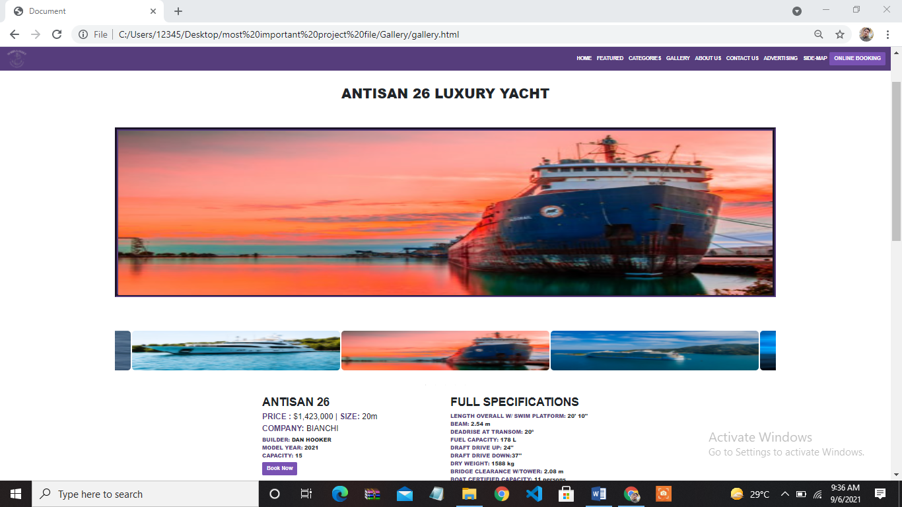

**BOOKING PAGE**

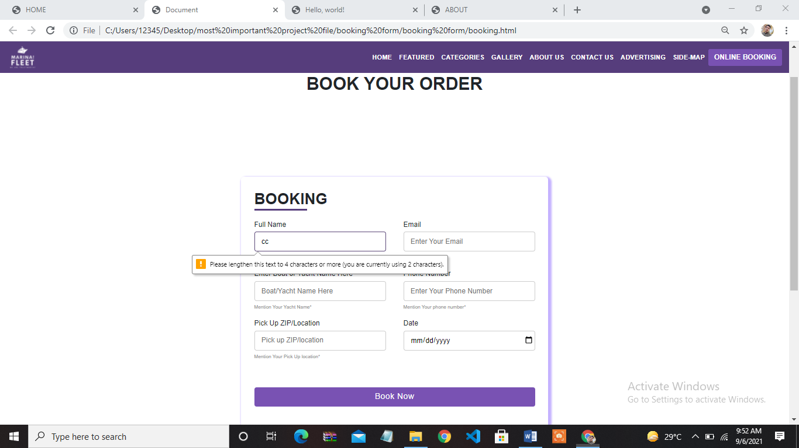

**ABOUT-US PAGE**

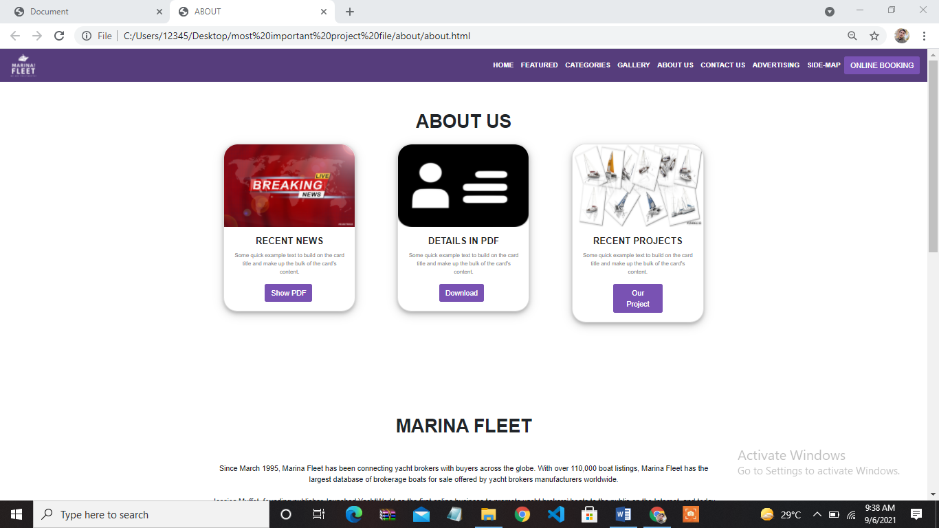

**ADVERTIZING PAGE**

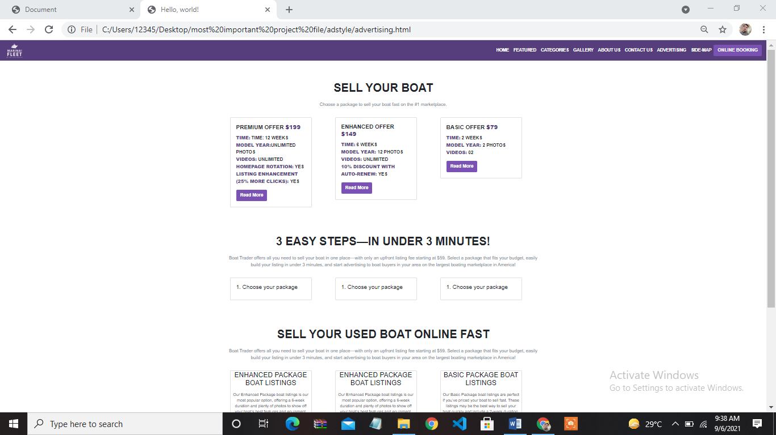

# **TASK SHEET:**

1. Syed Faraz Ali.
2. Saad khan.
3. Gulam Mustafa.

|  |  |
| --- | --- |
| Member Name | Task Done |
| Syed Faraz Ali | Analyzing, Problem Solving,  Coding, Logics, GUI |
| SAAD Khan | Categories Section |
| G Mustafa | Content downloading |

# **FINAL CHECK:**

|  |  |
| --- | --- |
| Particular’s | Checked |
| Validation | Done |
| Responsiveness | Done |
| Documentation | Done |
| Design | Done |